**PROJECT DOCUMENATION**

**PROJECT NAME : SMART IRRIGATION SYSTEM**

**Introduction :**

The Soil Moisture Monitoring and Automatic Irrigation System is a smart agricultural solution using an ESP32, a soil moisture sensor motor (water pump), and a ULN2003 motor driver. This system helps in automating plant irrigation by monitoring soil moisture levels and controlling the water supply accordingly.

When the soil moisture sensor detects dry soil, the ESP32 triggers the motor via the ULN2003 driver, turning on the water pump. Once the soil reaches the required moisture level, the system stops watering, ensuring efficient water usage and reducing manual effort. The ESP32 can also be connected to the internet for remote monitoring if needed.

**Components Required :**

1. **ESP32 Microcontroller**
   * Acts as the brain of the project, handling the communication, timing, and motor control.
   * Provides Wi-Fi and Bluetooth connectivity for remote control using MQTT.
2. **Arduino IDE Software**

* A programming environment used to write, compile, and upload code to ESP32 and other microcontrollers.

1. **Soil moisture sensor**

* Measures the water content in the soil and helps determine when irrigation is needed.

1. **ULN2003 driver**

* A motor driver IC used to control stepper motors by amplifying low-power control signal

1. **Connecting wires**

* Used to establish electrical connections between different components in the circuit.

1. **Cable for power supply**

* Provides the necessary voltage and current to power the ESP32 and other components in the project.

**Working Principle :**

1. **Soil Moisture Detection**

* The **soil moisture sensor** measures the water content in the soil.
* The sensor provides an analog or digital output based on the soil’s moisture level.

1. **Data Processing and Decision Making**

* The ESP32 microcontroller reads the sensor data and processes it.
* If the moisture level is below a set threshold, the system triggers the water pump via the ULN2003 motor driver.
* If the moisture level is sufficient, the system keeps the pump off to conserve water.

1. **Motor and Irrigation Control**

* The ULN2003 driver receives control signals from the ESP32 and powers the water pump accordingly.
* The pump irrigates the soil until the desired moisture level is reached.

1. **Wireless Monitoring & Remote Control**

* The ESP32, with built-in Wi-Fi and Bluetooth, sends real-time data to an IoT platform using MQTT.
* Users can monitor and control the system remotely through a mobile app or web dashboard.

1. **Power Management & Connectivity**

* The system is powered using a cable for power supply.
* Connecting wires ensure proper communication between all components.

**Circuit Diagram / Image :**

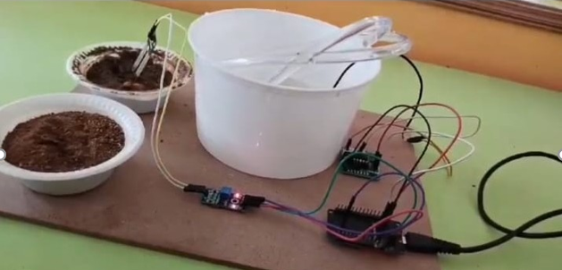

**Program :**

